RUNNING

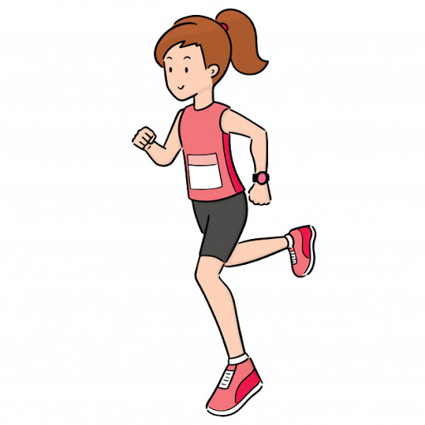

WALKING
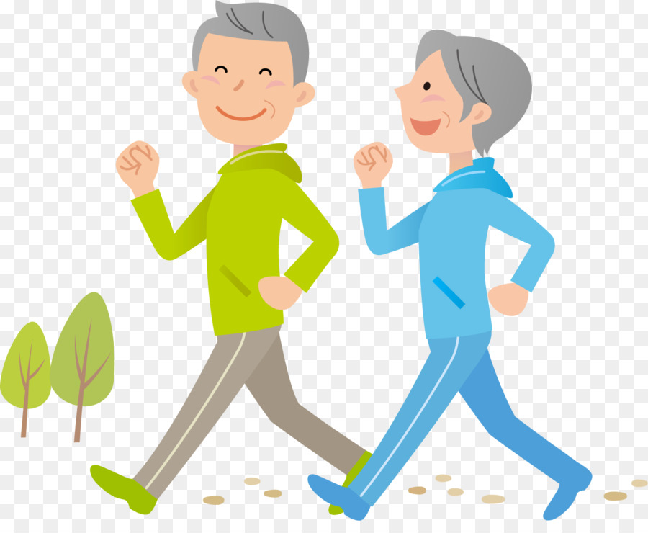

JUMPING

SWIMMING
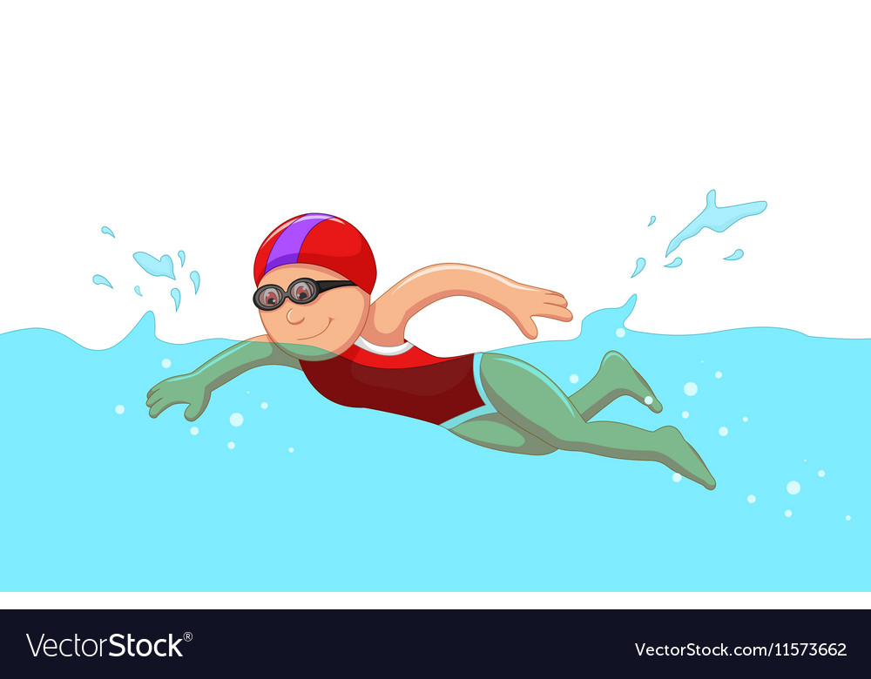

ACTIVITIES (aktivitis) – czynności

1. Walk (łolk) – chodzić
2. Run (ran) – biec
3. Jump (Dżamp) – skakać
4. Swim (Słim) – pływać

Przykładowe zdania:
1. I’m going for a walk with my dog. – Idę na spacer z psem.
2. My parents run every evening. – Moi rodzice biegają codziennie wieczorem.
3. Rabbit jumps on the meadow. – Królik skacze po łące.
4. My friend can swim very well – Mój kolega umie bardzo dobrze pływać.

Piosenka: „Walking,Walking”
https://www.youtube.com/watch?v=fPMjnlTEZwU
„Walking, Walking” (tekst)
Walking walking. Walking walking.
Hop hop hop. Hop hop hop.
Running running running. Running running running.
Now let’s stop. Now let’s stop.
Walking walking. Walking walking.
Hop hop hop. Hop hop hop.
Running running running. Running running running.
Now let’s stop. Now let’s stop.
Tiptoe tiptoe. Tiptoe tiptoe.
Jump jump jump. Jump jump jump.
Swimming swimming swimming.
Swimming swimming swimming.
Now let’s sleep. Now let’s sleep.
Wake up!
It’s time to go!
Are you ready to go fast?
Okay!
Walking walking. Walking walking.
Hop hop hop. Hop hop hop.
Running running running. Running running running.
Now let’s stop. Now let’s stop.
Walking walking. Walking walking.
Hop hop hop. Hop hop hop.
Running running running. Running running running.
Now let’s stop. Now let’s stop.
Whew!

1. Colour the picture
