TEDDY BEAR DAY

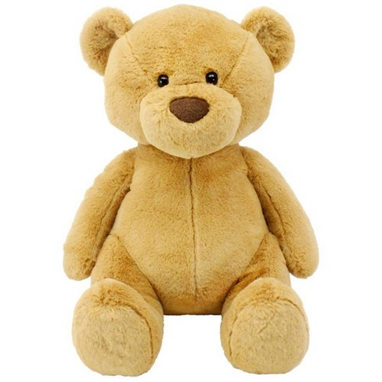
My teddy bear.

Piosenka „Teddy bear song”
My teddy bear has two eyes, two eyes, two eyes.
My teddy bear has two eyes. I love my teddy bear.

My teddy bear has one nose, one nose, one nose.
My teddy bear has one nose. I love my teddy bear.
My teddy bear has two ears, two ears, two ears.
My teddy bear has two ears. I love my teddy bear.

My teddy bear has two arms, two arms, two arms.
My teddy bear has two arms. I love my teddy bear.

My teddy bear has two legs, two legs, two legs.
My teddy bear has two legs. I love my teddy bear.
My teddy bear has four paws, four paws, four paws.
My teddy bear has four paws. I love my teddy bear.

Słówka:

TEDDY BEAR – PLUSZOWY MIŚ

EYES – OCZY

NOSE – NOS

EARS – USZY

ARMS – RAMIONA

LEGS – NOGI

PAWS - ŁAPY

